Accessible public warnings under Article 11: proposed language for the draft General Comments
Submitted by International Deaf Emergency (IDE), a Deaf led organization and international member of the World Federation of the Deaf | August 2026
Focused input relevant to the two draft General Comments on Article 11, particularly accessible warning dissemination and emergency communication.

The protection gap
Many public warning systems use audible signals or generic vibrations that announce an alert without identifying the hazard, urgency or protective action. This creates particular barriers for Deaf, hard of hearing and DeafBlind persons. It can also leave blind and partially sighted persons unable to identify the danger when the sound is generic. Many warnings communicate nothing actionable through a channel accessible to DeafBlind people. The same gap exists in the built environment, where alarms may signal danger without identifying the hazard or the action required. A warning that a person cannot perceive, understand and use provides no effective protection.

The proposed paragraph
States parties should ensure that public warning and emergency communication systems provide redundant visual, auditory and tactile attention signals, together with timely, equivalent and understandable warning content in accessible formats. Each attention channel should independently indicate that an urgent warning has been issued. Where a hazard rhythm is used, its validated hazard family meaning should be rendered consistently through every supported tactile, visual and auditory channel, so that people who rely on touch, sight or sound can identify the same danger. No essential element, including the urgency or severity of the emergency, the type and location of the hazard, and the protective action required, should be conveyed solely through sound, colour or another single sensory feature. Persons who rely on touch, including DeafBlind persons, must be able to detect warnings through tactile means and access the full message through compatible assistive technologies or other appropriate tactile and DeafBlind communication methods. These obligations apply equally to warning and alarm systems in the built environment, which should convey not only that danger exists but also the hazard and the protective action required. The initial alert must itself contain the essential protective action. The complete warning and supplementary detail should be available through the warning medium or an immediately accessible and interoperable linked channel, in plain language, Easy Read, national sign languages through qualified interpreters and Deaf presenters as appropriate, captioned formats, and formats compatible with screen readers and refreshable braille, according to users’ communication requirements. States parties should develop, procure, test and monitor such systems in close consultation with, and with the active involvement of, representative organizations of persons with disabilities, particularly organizations of Deaf, DeafBlind, blind and partially sighted persons.
The structure is deliberate. DETECTION is redundant across the senses. The FULL WARNING, including the action, is guaranteed in accessible language.

Every channel serves everyone: one hazard rhythm across all supported channels
The redundancy is universal design under Article 2, not a set of parallel special accommodations. A hazard rhythm is shared across touch, light and sound, allowing each person to receive it through every channel they perceive. Where a validated rhythm is used, its sound rendering must allow people who rely on auditory information, including blind and partially sighted people, to identify the hazard family without sight. Its visual and tactile renderings provide the same immediate cue for people who rely on sight or touch, including Deaf, hard of hearing and DeafBlind people. The rhythm identifies only the family. Accessible speech, text, national sign languages or braille provides the specific event and required action. Colour, with a colour independent mark count, can convey severity without becoming the sole carrier. The design also benefits anyone asleep, in noise, in darkness or carrying a device in a pocket. Each person benefits from every channel they can perceive. Article 4(1)(f) requires States to promote systems designed for use by all.

The Convention basis
Article 11 obliges States to take all necessary measures to ensure the protection and safety of persons with disabilities in situations of risk. It is read with Article 2 on accessible communication and universal design, Article 4(1)(f) on universal design, Article 4(3) on close consultation, Article 5 on equality, Article 9 on accessibility of information, emergency services and buildings, Article 21 on access to information and sign languages, and Article 30(4) on sign languages and Deaf culture. General Comments Nos. 2 and 7 also establish the duties of accessibility and active involvement.

What a complete warning answers
Every complete warning answers five functional questions: Is this an emergency? How serious is it? What is the danger? What should I do now? Where can I obtain the full information in my language and format? This sequence is not exhaustive. The full warning must also identify the affected place, time, duration and authenticated source. Hazard and severity cues may be reinforced through validated attention signals. The protective action and complete information must be available in accessible formats.

Design principles advanced in IDE’s pending FCC comments
IDE’s draft FCC comments (reference 2) advance the following proposals for participatory evaluation. They are evidence of technical feasibility, not FCC findings or validated population outcomes:
- A symbol can identify a danger but cannot carry a full warning. It should accompany an equally prominent action first instruction in plain language.
- Where a learned hazard pattern is used, the pattern should remain stable across severity levels. Separate, tested features should convey severity.
- An all clear should be an affirmative, authenticated message that names what ended. Silence is not evidence of safety.
- Urgent warnings should repeat within a validated window until acknowledged, then remain available as an accessible status.
- People should be able to test their warning channels in advance so a failure is not first discovered during an emergency.

Feasibility and precedent
- WFD and WASLI identify the nature, location and severity of an emergency and the action required as essential information, with national sign languages central to delivery (reference 1).
- United States rules require provider support for pre scripted American Sign Language alert templates by 12 June 2028. The FCC is also consulting on hazard symbols and attention signals (reference 2).
- IDE offers a working prototype, a public and royalty free specification, Apache 2.0 code and a conformance suite as feasibility evidence, not an exclusive solution (reference 3). Tactile and auditory patterns must be produced and validated with the people who rely on them. A Deaf and DeafBlind participant study is underway. Blind and partially sighted participants will also be invited as experts in auditory access to test identification and confusion between sound rhythms. The closing pages illustrate the framework.

The request
That both draft General Comments reflect the proposed paragraph or its substance: accessible detection; the full warning, including the action, in an accessible format; tactile detection where touch is the only channel; built environment alarms that identify the danger and required action; and development and testing with Deaf, DeafBlind, blind and partially sighted communities.

The framework, illustrated
Illustrative examples, not prescriptions. The proposed obligation is technology neutral and does not require this particular interface or vocabulary.

Figure 1. One flood alert from the reference prototype
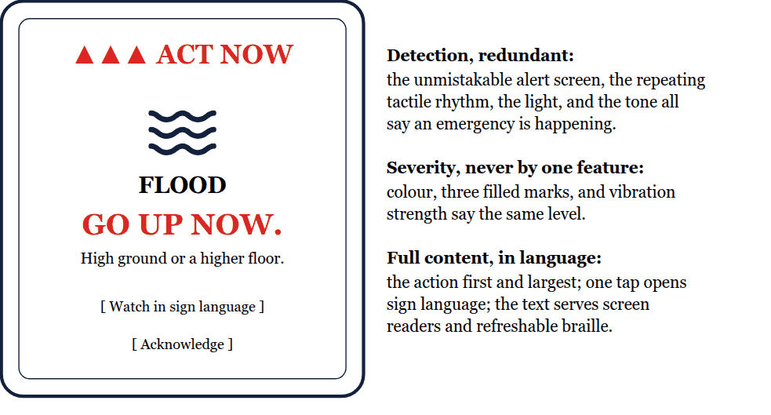
Any single attention channel suffices to detect the emergency. The full message, including the action, is guaranteed in accessible language. Every figure is drawn still, and nothing flashes.
Figure 2. One hazard rhythm across three channels, driven by one clock
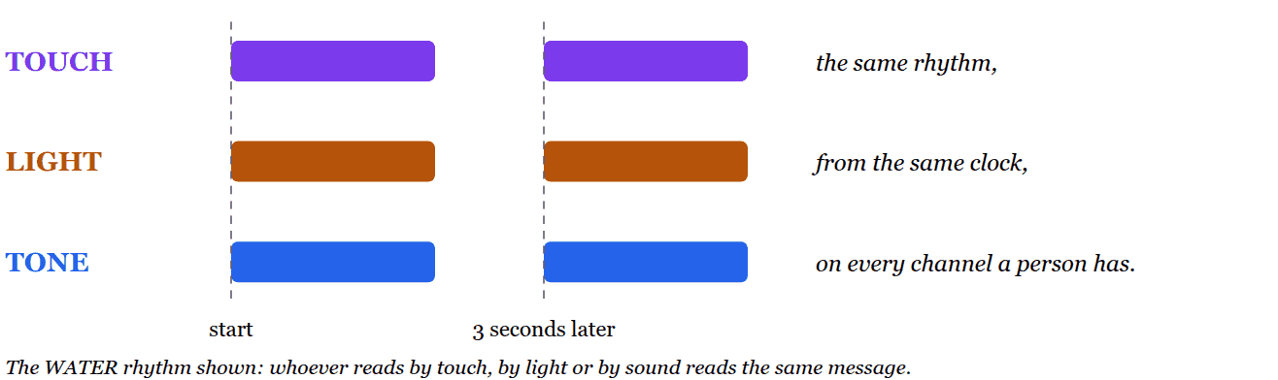

Figure 3. Detection and understanding: which channels carry what
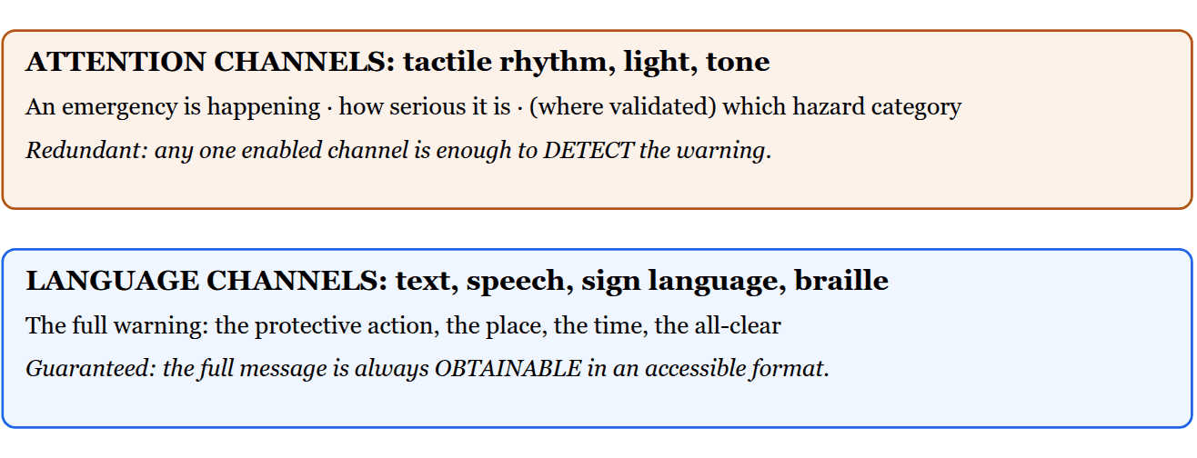
Detection plus accessible full content. The protective action is selected by the alert originator and stated in language. A device never infers the action from a vibration alone.

Figure 4. The draft hazard-family rhythm vocabulary, drawn to scale
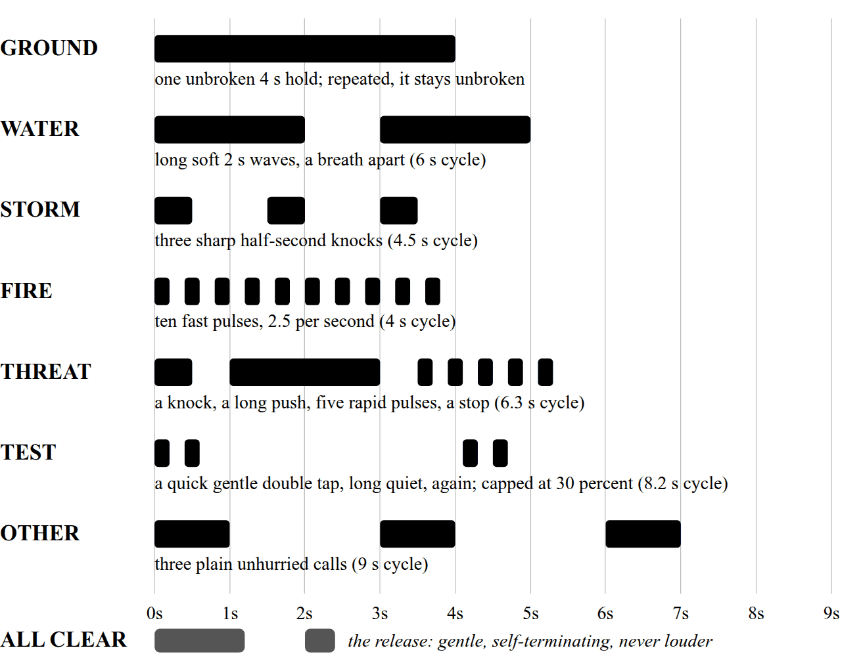
Each row shows one cycle of one family’s rhythm. The same timing structure can be rendered through touch, light and sound; dark blocks are on and white space is silence. The seven families demonstrate the feasibility and diversity of a small learned vocabulary. They remain illustrative, non-normative design hypotheses for participatory validation with affected users. For participants who rely on auditory information, including blind and partially sighted participants, testing will ask whether sound alone permits timely and accurate hazard family identification. The rhythm supplies an immediate family cue and does not replace the accessible message stating the specific event and required protective action.

Figure 5. The same vocabulary in devices and buildings
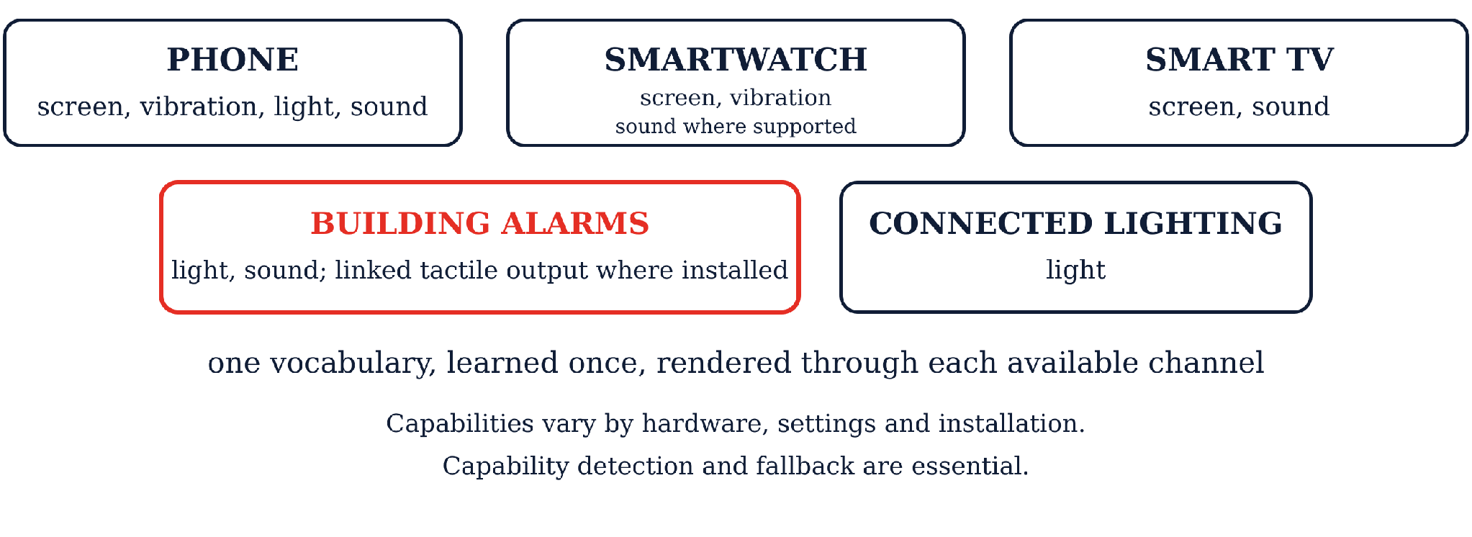
Different emergencies may require opposite protective actions, including evacuation, moving to higher ground or sheltering in place. Each renderer must therefore communicate the required action explicitly and accessibly, while capability detection and fallback prevent reliance on an unavailable channel.

References:
1. WFD and WASLI, joint statement on emergency communication for deaf sign language users (2015).
2. FCC 26-38, PS Dockets 15-91, 15-94, 25-224 (symbols at paragraphs 77 to 82, earthquake alert enhancements at 83 to 86; comments due 31 August 2026); ASL template rule 47 C.F.R. § 10.500(e)(2), compliance 12 June 2028 (DA 25-1078).
3. The reference specification and conformance suite, github.com/Signlo/three-senses, archived at DOI 10.5281/zenodo.21977982.

