The Three Senses framework: an introduction

One hazard rhythm across supported channels: accessible emergency warnings through touch, light and sound
International Deaf Emergency (IDE) | August 2026

The problem
A warning protects only when people can perceive it, understand it and act. Many public warnings and building alarms still rely on one generic siren, buzz or screen cue for every danger. A person may detect that something is wrong without learning whether the danger is fire, flood, severe weather or a test, even though the protective action can be very different. A signal may also be unavailable to Deaf and hard of hearing people, blind and partially sighted people, DeafBlind people, people who are asleep, and anyone in noise or unable to look at a screen. The IASC Guidelines report that persons with disabilities can face disaster mortality rates two to four times higher than persons without disabilities and call for accessible early warning systems and information in multiple accessible formats. Better warnings benefit everyone.

The framework
The Three Senses framework is a small, royalty free presentation vocabulary. Each hazard family has one timing pattern, rendered through every touch, light and sound channel that a device or setting supports. Each person receives the family cue through the channels they can perceive. This includes auditory access for blind and partially sighted people, visual and tactile access for Deaf and hard of hearing people, and compatible tactile and communication access for DeafBlind people. The aim is universal design for everyone, with no essential warning information dependent on one sensory feature.
The work is divided between attention and language. A rhythm on the skin, in light or in sound can carry that an emergency is happening, its severity and, after validation, the hazard family. Text, speech, national sign languages, braille ready formats, plain language and Easy Read carry the full warning: the event, place, time, protective action and all clear. The rhythm identifies only the family; it never replaces the full message. Severity is conveyed with more than color alone and never by changing the family rhythm.
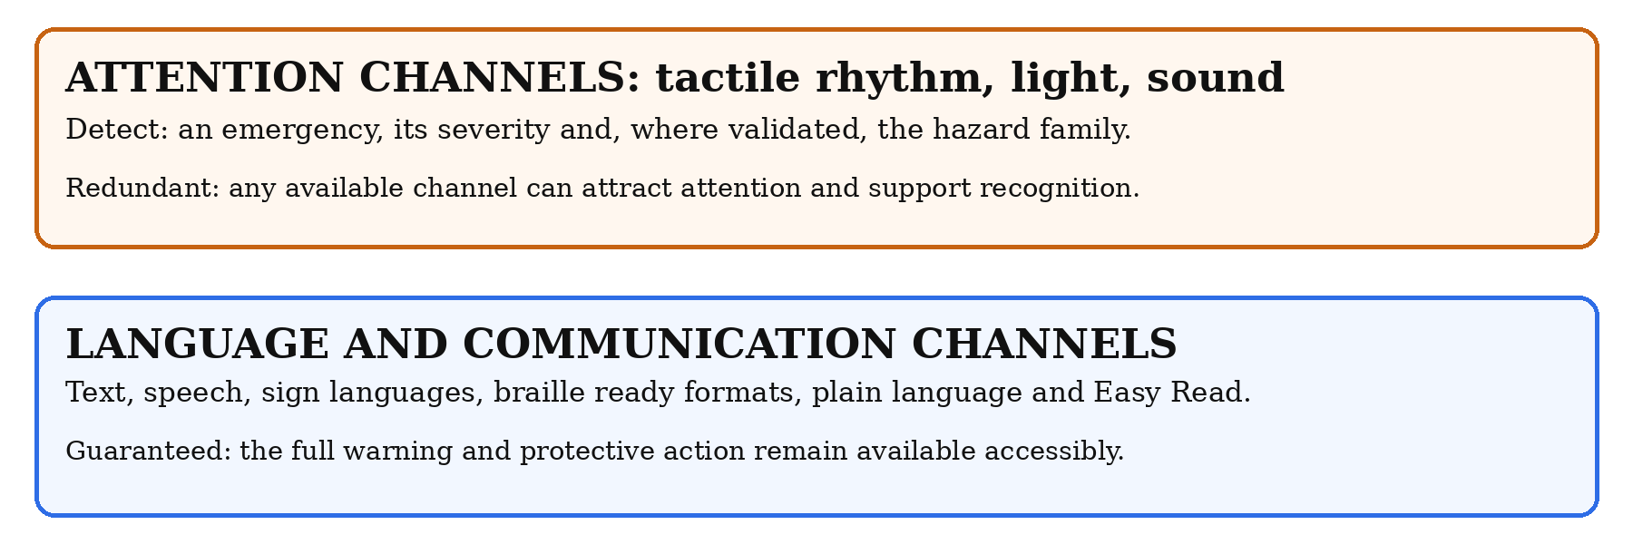
Detection and understanding: what the attention channels can carry, and what accessible communication guarantees.

The draft rhythm vocabulary
Each hazard family has one short timing pattern. The draft rhythms are design hypotheses informed by hazard motion and selected sign language imagery. Water uses long waves, ground one sustained hold, storm three knocks and fire a series of fast pulses. The patterns differ in more than one feature, including pulse and gap length, so they can be distinguished by touch, sight or hearing. The all clear is deliberately different: gentle, self terminating and never louder. Silence alone is never treated as proof of safety.
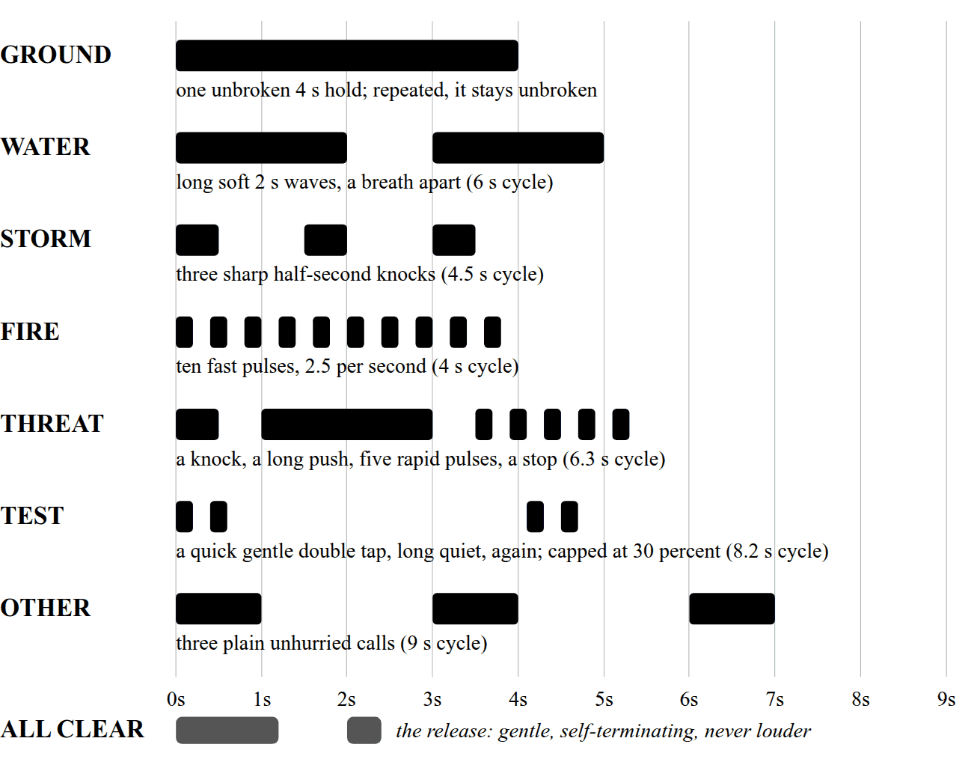
Draft hazard family vocabulary, drawn to scale. The same timing structure is rendered through each supported channel. Dark blocks are active periods and white space is silence.
The seven families, water, storm, ground, fire, threat, other and test, have a published crosswalk from common alert event classes. They must be tested across cultures, national sign languages and disability groups. Whether seven is the right number, and whether every pattern earns its place, is exactly what participatory validation must decide.
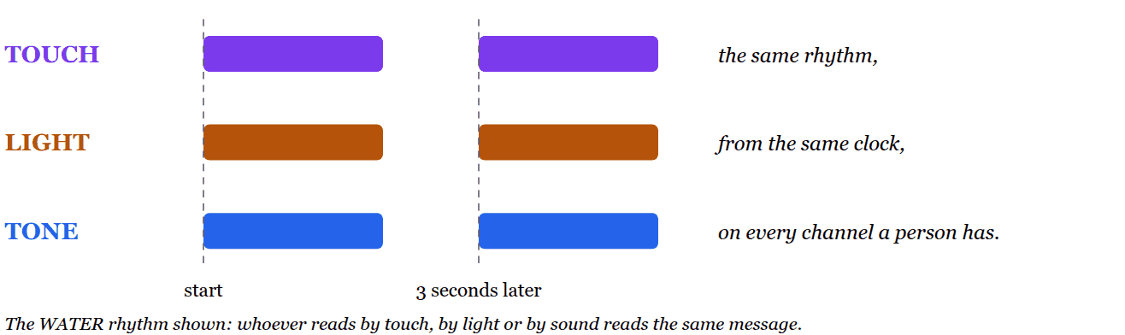
One timing pattern, three supported channels, one clock.

One vocabulary, many devices
The vocabulary is semantic, not tied to one device. Each device renders the timing pattern only through the channels it supports. A phone may use its screen, vibration, light and sound. A smartwatch may use its screen, vibration and, where supported, sound. A smart television can use its screen and sound. Building alarms can use light and sound, with linked tactile output where installed. Connected lighting provides a visual channel. Capability detection and fallback are essential. Visual cues must remain within photosensitivity safety limits and offer a steady light option.
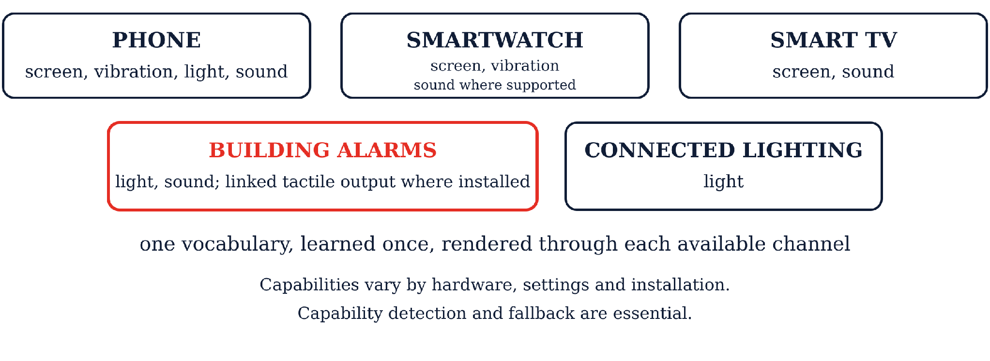
One vocabulary, rendered through the channels each device or setting actually has.

Humanitarian settings and limits
IDE's working phone application demonstrates technical feasibility; it is not an assumption that everyone has a smartphone, power or connectivity. Field use must also address shared and basic devices, local warning infrastructure, power and network loss, maintenance, training, literacy, local languages, shelters and camps. Delivery choices must be shaped with local organizations of persons with disabilities, authorities, responders and affected communities.

Status and evidence
The framework runs end to end in a reference application on unmodified consumer phones. The specification, machine readable vocabulary, developer kit and machine checkable conformance suite are published royalty free for any agency or vendor to implement. Evidence so far consists of expert panel review and engineering testing. A structured study with Deaf and DeafBlind participants is underway. Blind and partially sighted participants will be invited as experts in auditory access to test whether sound rhythms alone support timely hazard family recognition. Broader validation should include people with intellectual and psychosocial disabilities, children, older people, people with varied literacy and language backgrounds, local organizations of persons with disabilities and responders.
IDE shared a proposal with IDA and WFD on 19 August 2026 for possible engagement with the CRPD Committee. IDE plans to file comments in the United States FCC alerting proceeding by 31 August 2026. These are IDE materials and do not presume endorsement by the Disability Reference Group, IASC, IDA, WFD or the CRPD Committee.

Learn more
Standard, code and conformance suite: github.com/Signlo/three-senses | DOI 10.5281/zenodo.21977982 | Summary: ideafe.org/standard
Emmanuel Jacq, President, International Deaf Emergency (IDE)
emmanuel.jacq@ideafe.org | ideafe.org | Silver Spring, Maryland, USA

